Unit 4 - Introduction to Forces

Teacher Notes

# Instructional Goals

1. Newton's 1st law (Galileo's thought experiment)

Develop notion that a force is required to *change velocity*, not to *maintain motion*.

Constant velocity does not require an explanation.

2. Force concept

View force as an interaction between an agent and an object.

Choose system to include objects, not agents.

An interaction between object and agent results in a pair of forces equal in magnitude but opposite in direction.

3. Force diagrams

Represent the interactions between system and surroundings using system schema.

Correctly represent forces as vectors originating on object (point particle).

Use the superposition principle to show that the net force is the vector sum of the forces.

4. Statics

∑F = 0 produces same effect as no force acting on object.

Decomposition of vectors into components (optional).

5. Field Theory

Forces ‘at a distance’ are actually forces acting within a ‘field’.

Field force = matter field property * field strength

(matter field property - i.e. “mass”, “electric charge”, etc.)

6. Energy Connections

Changes in energy (kinetic) are discussed as a result of applied forces.

The role of force as an energy *transfer* mechanism is discussed.

7. Computational Modeling Skills in Pyret

Modify and create programs that represent the application of force to an object as incremental changes in its velocity.

Use displays of dynamic images of arrows to represent force vectors.

Create conditionals to represent the motion of an object as a piecewise function.

Write a function for force as a function of charge.

Essential Questions

Why do objects move?

What is a force?

What are different types of forces?

How do we represent forces?

What do we mean by balanced and unbalanced forces?

What is the effect of balanced and unbalanced forces on a system?

How is balanced force related to uniform motion?

How is balanced force related to being at rest?

What are fields?

What is field strength?

# Overview

In this unit, students are introduced to the first half of Newton's Modeling Cycle:

a) From motions (read: changes in velocity), infer forces

b) From forces, deduce changes in motions

Changes in Velocity

Deduce

Infer

Forces

Changes

in Velocity

Forces

infer

deduce

We are moving from the realm of *descriptive models* (kinematical laws of motion) to that of *causal models*: dynamics.

"The dynamical laws connect interactions with kinematics and so determine the particle motions. The subtle, almost superfluous, role of Newton's First law should be noted. A *free particle* is defined as one on which the sum of the forces on the system is zero (F=0). This provides a criterion distinguishing inertial systems from other reference systems, and to say that free particles have constant velocities is to say that they define a uniform time scale. The definition of this time scale is an essential prerequisite to Newton's Second Law. The First Law has been previously classified as a kinematical law, but here it is classified as a dynamical law because it is an essential prerequisite to the Second Law and it involves the concept of force."[1]

It is essential for students to recognize that a system with constant velocity differs from one with non-constant velocity, and that only *changes* in velocity require an interaction between an agent and an object. We define this interaction as the concept of *force*. After the inertia ball pre-exploration, students will get the sense that force is required to change the motion of an object. This is reinforced by Activities 2 and 3, and one can use worksheets 1 and 3 as an opportunity to apply the force concept in a *qualitative* way. It is important to carefully treat how to go about drawing force diagrams in which one represents the object as a point particle. In this unit, we will introduce the concept of the identification of systems and will do so by drawing dotted lines around the system being studied to help students distinguish between the object/system and the agent(s) that affects its motion. Significant attention will also be paid to identifying forces based on the type of interaction, the system, and agents involved in the interaction. This care in building the idea of a *force as an interaction* will pay large dividends when Newton’s Third Law is introduced in Activity 4.

Some students may notice the connection between the magnitude of the acceleration of a freely falling object (end of unit 3) and the gravitational field strength. Postpone discussion of this connection until Unit 5 (Unbalanced Forces) in which we will quantify the relationship between force, mass, and acceleration. This way students are more likely to understand the *g* in the *Fg* = *mg* equation as the *gravitational field strength* (desirable) as opposed to the quite different concept of the *acceleration due to gravity*, whose magnitude just happens to be the same.

The gravitational force vs. mass experiment is followed with post-lab discussion and a second lab using Pyret, both of which require students to think about the effect of changing mass or gravitational field strength on the gravitational force on an object. Students will also practice determining unknown weights and masses using the mathematical model developed in the previous activity (*Fg* = *mg*).

Students will practice drawing simple force diagrams which require no vector components, and using those diagrams, the equation for equilibrium ($\sum{\overset{⃑}{F}}=0$), and *Fg* = *mg* to write the equations that will allow them to solve for unknown forces.

As a final unit activity and lab practicum, students will further investigate the concept of ‘force fields’ through a study of electromagnetic forces using Millikan’s Oil Drop experiment. The goal of this experiment is to establish a pattern between forces exerted by fields, i.e. gravitational fields and electric fields.

|  |
| --- |
| Ffield = matter field property * field strength |

When students have gained confidence representing forces and their effects on system motion without the use of vector components then further mathematical treatments can be considered. In this introductory course, we choose not to decompose force vectors using trigonometry. However, it is important to expose students to qualitative analyses of such problems, as not all forces act parallel to the coordinate axes. Additional treatments are offered as supplemental resources for this unit.

At this point students should be able to do worksheet 5 which requires students to produce force diagrams for objects that have forces that are not along the coordinate axes including objects hanging from ropes at angles, and objects on inclines.

**NGSS Crosscutting Concepts to be addressed in Unit 4:**

|  |  |
| --- | --- |
| **Crosscutting Concept:** | **Specific Example(s):** |
| 1. Patterns | Observed patterns in motion, balanced or unbalanced forces, and changes in velocity guide organization and classification, and prompt questions about relationships and causes underlying motion. |
| 2. Cause and Effect | Deciphering causal relationships (changes in velocity), and the mechanisms by which they are mediated (forces). |
| 3. Scale, Proportion, and Quantity | In considering forces and motion, it is critical to recognize what is relevant in terms of magnitude (scale) of force, and the time a force is applied, and to recognize the proportional relationship between the magnitude of forces and the magnitude of velocity change. |
| 4. Systems and System Models | The force model is used for understanding and predicting the behavior of systems (changes in velocity). Computer representations are used to model the motion of systems. |
| 5. Energy and Matter | Tracking energy flows, into, out of, and within systems helps one understand their system’s behavior. This unit emphasizes the role of forces in transferring energy and how that changes the behavior of systems. |
| 7. Stability and Change | Conditions that affect stability (the presence of unbalanced or balanced forces) and factors that control rates of change (changes in velocity) are critical elements to consider and understand. |

# 

# Sequence

1. Activity 1: Pre-Exploration—Broom Ball
2. Class Discussion: Force Identification and Notation
3. Reading 1: Types of Forces and Force Representation
4. Activity 2: Forces on an Air Puck Demonstration
5. Reading 2: Force Diagram and System Schemas
6. Worksheet 1: Force Diagram Practice
7. Quiz 1a or Quiz 1b
8. Activity 3: Air Hockey Table Pyret Simulation
   1. Activity 3a: Air Hockey Table
   2. Worksheet 2: New Pyret Skill: Conditionals
   3. Activity 3b: Air Hockey Table - Broken
   4. Activity 3c: Air Hockey Table - Broken
9. Worksheet 3: Hockey Table Analysis
10. Activity 4: Pairs of Forces Stations
11. Worksheet 4: Pairs of Forces
12. Activity 5: Gravitational Force vs. Mass Lab
13. Class Discussion: What are mass and weight and how are they related?
14. Activity 6: Gravity on Different Planets Pyret Simulation
15. Reading 3: Force Fields
16. Worksheet 5: Electric Force and Electric Fields
17. Activity 7: Millikan Oil Drop Practicum Pyret Simulation
18. Worksheet 6: Forces in Equilibrium
19. Unit Review: The Model so Far
20. Unit Test

SUPPLEMENTAL ACTIVITIES

1. Activity 8: 2-D Force Diagrams
2. Worksheet 7: Force Diagrams 2
3. Quiz 2
4. Worksheet 8: Multiple Object Systems

*As a reminder, we must circle back to Unit 1 – Qualitative Energy Unit. Students should be directed to think back to the activities examined in the Observation Stations. These should provide a launch point into all the discussions for this unit, but this time with a stronger focus on getting deeper understanding and revealing Newtonian physics!

# 1. Activity 1: Pre-Exploration - Broom Ball

# **Purpose**

The purpose of this activity is to give the students in your class a common experience from which to commence force concepts.

## Apparatus

* Broom with flexible bristles and a plastic casing at the top of the bristle end. (You can find these brooms at the Dollar Store.)
* Bowling ball
* Large pail containing sand
* Course marked off with tape on the floor (see diagram below). *Teacher note: Blue painters’ masking tape or electrical tape work best for tape removal after the activity.*

Start

No Touch Zone

Pail

Start

Start

Start

Pail

**Pre-activity discussion**

The rules of the game:

* Play Broom Ball as a relay race.
* Divide the class into two teams. Place half of the team at each end of the course.
* The bowling ball should be at rest at one end of the course. Each student will run the course from whichever end he/she is.
* The ball may be manipulated only with the bristles of the broom. If any part of the broom other than the bristles touches the ball that is a penalty. If the ball touches any obstacle in the room, such as furniture, a student’s foot, etc., that is a penalty.
* Start the clock when the first player takes off. The student should follow the course. They must go all the way around the large pail (360 degrees), through the no touch zone without touching the ball with the broom, around the corner and bring the ball to a complete stop in the starting box, before the next player takes off reversing the course.
* After the last team member has completed the course stop the watch and add a second for each penalty while the ball was in play.
* The team with the shortest time wins. You decide the reward.

Note: This activity can also be completed using ‘rubber mallets’ in place of the broom.

## Lab performance notes

Select members of the opposite team to help with timing, but make sure that you as teacher determine all of the penalties. To eliminate arguments, give the guilty team 5 penalty points.

## Post-activity discussion

After the game is over and the winning team commended, ask the students what was challenging about Broom Ball. Ask only for *difficulties* with the ball. Then ask them what broom remedies helped overcome those difficulties. Make a list of each on the board. Your students might mention:

* Difficulties
  + Starting
  + Stopping
  + Changing direction
* Broom Remedies
  + Pushing the ball from behind
  + Pushing the ball from the front/placing the broom on top of the ball
  + Pushing the ball from the side, or at 90 degrees to the direction of the motion

It is important that students determine that the force they applied and the change in velocity are *always* in the same direction. **If the force is continuously applied in the same direction as the existing velocity, the velocity will increase. If the force is applied in the opposite direction, however, the velocity decreases.**

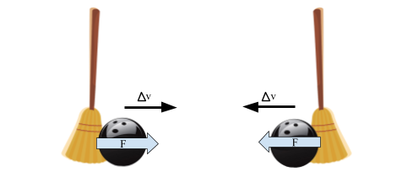

* **Energy connections**
  + How was energy added to the system?
    - Look to bring out the term ‘working’ as discussed in Unit 1, as a result of the *force* acting as it moves.
    - What happened when the ball was struck in the same direction as the ball was moving?
    - What happened when the ball was opposite in the same direction as the ball was moving?
  + Was there a way to hit the bowling ball *without* changing the ball's energy?

2. Class Discussion – Force Identification and Notation

# Demonstration – The Effects of Forces on Motion

## 

## Apparatus

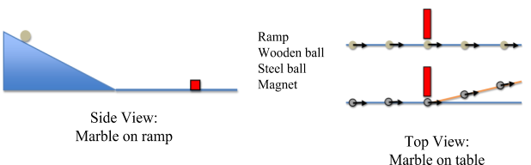

Use a ball on ramp to create a constant velocity along the table top for a rolling ball. The wooden ball rolls past a magnet and continues to travel in a straight line. The steel ball rolls past a magnet and is pulled ‘off path’ with a slight change to the path.

Side view

Focus the discussion on the motion while the balls are rolling on the table.

* Why are the balls moving at constant velocity on the table?
* Is the Earth still acting on the balls?
* If the Earth is still acting on the balls, then why don’t they change velocity (vertically)?

[The table acts on the ball, with a force called ‘normal’. It is recommended to use the term ‘perpendicular’ as well and using the symbol “⊥” to denote the ‘Normal’ force, to help the students recognize the direction it acts.]

Finally, focus on a book sliding across the table. Why does the book not travel at a constant velocity? [The table acts on the ball, with a force called ‘friction’.]

|  |  |  |  |
| --- | --- | --- | --- |
| *Fundamental Forces* | | | |
| **Gravitational** | **Electromagnetic** | **Strong Nuclear** | **Weak Nuclear** |
| Gravitational (g)  Note: Fg will be used throughout these materials to denote a constant gravitational force and FG will be used for the gravitational force as calculated using the universal law of gravitation. | Friction (f) |  |  |
| Normal (N) *or*  Perpendicular (⊥) |
| Tension (T) |
| Electrostatic (elec) |
| Magnetic (M) |
| Push/Pull (P) *or* Applied (A) |

For this unit, as in the units addressing momentum and unbalanced forces, the notation Fg is the only variation addressed. Universal gravitation will be studied in the unit on fundamental forces and fields and it is at this time that the notation FG can be added.

Video: Veritasium – What is a force?

<http://www.youtube.com/watch?v=GmlMV7bA0TM>

3. Reading 1 – Types of Forces and Force Representation

At this time, it is only the type of force and its representation that will be emphasized. Following the second activity, system schema will be introduced to allow students to diagram interactions between objects and add agent-object notation to force subscripts.

4. Activity 2 – Forces on an Air Puck Demonstration

## Pre-demonstration Teacher Background

The naive belief that forces are properties of objects and that forces are carried along with objects, perhaps wearing out over time or distance, is a persistent belief reminiscent of the pre-Newtonian teachings about “impetus.” The presence of impetus assures an on-going motion; its disappearance will result in an object coming to rest. It is an indirect goal of this activity to provide students an opportunity for arguing that a free particle, i.e. one subject to a zero sum of the forces, will have a constant velocity. Also, students should conclude that any apparent change in velocity of an object indicates that a non-zero sum of the forces is acting upon it, provided that the observer is in an inertial (non-accelerating) frame of reference.

*The use of “sum of the forces” and F rather than “net force” and Fnet is established to reinforce that the net force is not a force separate from the gravitational and electromagnetic forces acting on the object but rather the result of the summation of the forces acting on the object.*

## Apparatus

* Hover Puck, air table, or block of dry ice
* large level table, clean tile floor. or large (4’ x 4’ or larger) flat whiteboard (if using hover puck or dry ice)
* gloves (if using dry ice)

## 

## Performance notes

Where possible, depending on which apparatus you use, you will want to demonstrate each of the following situations:

1. Object at rest on a level surface—air source turned off.
2. Object at rest on a level surface—air source turned on.
3. Object in motion on a level surface—negligible friction.
4. Object in motion, being pushed in the direction it is moving.
5. Object in motion, being pushed in the opposite direction it is moving.
6. Object in motion, being pushed perpendicular to the direction it is initially moving on a level surface.
7. Object in motion, being pulled perpendicular to the direction it is moving at all times.
8. Object in motion on a level surface for which friction is not negligible.
9. Object on inclined surface—negligible friction.

One way to apply a constant force to an object is to attach a rubber band to it and to pull the object while keeping the rubber band stretched a constant amount. Another very nice way to apply a constant force is to push the object with a strong stream of air such as one from the output of a shop vacuum or from a leaf blower. The nice thing about the air stream method is that it can be used to apply fairly constant forces or to provide quick impulses. *(The term ‘impulse’ is being used here for clarification purposes for instructors but* ***should not*** *be used with your students at this time. Impulse will be discussed in a later unit.)* You can purchase dry ice at many local supermarkets. Two to three pounds will last through the day if kept in a cooler. Get pieces that have a smooth surface and are at least 2" thick.

* With a cordless drill you can firmly attach a drywall screw into the block.
* Make the bottom surface as smooth as possible by rubbing it with fine sandpaper.
* If the table is level, the block should remain motionless, floating on a layer of sublimed CO2. Given an impulse, the block will undergo uniform translational motion until someone catches it before it falls off the table. You and student helpers can play catch with the sliding block.
* Make the point that when no force acts on the block in the horizontal direction, the block maintains constant velocity.
* Point out that an impulse applied perpendicular to the original trajectory does not result in the block making a right-angle turn.
* Be sure to ask why they think the block continues to move once it leaves the hand. Some are likely to answer "… due to the force of the hand."
* Attach a rubber band to the screw in the top of the block. Apply a constant force by keeping the rubber band stretched a constant amount. The block clearly accelerates.

Student conclusions should be clear: in order to change the velocity (speed *and/or* direction), a force must be applied; in all of these cases, the force is a contact one.

Goals:

* Develop F = 0 (for constant velocity) & ΣF ≠ 0 (for non-constant velocity).
* Draw a ‘force diagram’ for each motion and situation but leave sharing the name of the diagrams until the concept above is fully developed.

**Energy connection:**

* What happens to the energy when the forces are balanced?
* What happens to the energy when the forces are unbalanced?

## 

## 5. Reading 2 – Force Diagram and System Schemas

This reading introduces system schema and agent-object notation to add to the previous representations of force.

System schema can be used to diagram the interactions between objects prior to constructing a force diagram.

For example:

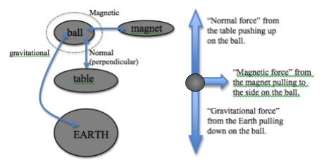

Agent-object notation adds two additional subscripts to each notation of force acting on an object. The first subscript names the type of force acting on the object, the second one is the “agent” or “dealer” of the force, the thing outside the system producing the force. The third subscript is the “object” or “feeler,” in other words the object or system experiencing the force.

# 6. Worksheet 1: Force Diagram Practice

For each system on this worksheet, students are asked to fill in a table, drawing system schema and a force diagram for each object or system. The table also asks students to establish sign conventions (up = positive; right = positive), write a sum of forces equations, and define the subscripts used for each force.

7. Quiz 1

Two versions of this quiz are provided. Both quizzes focus on force representation and force diagrams.

8. Activity 3 - Air Hockey Table Pyret Simulation

This simulation shows a puck moving across an air hockey table and takes place in three stages. In the first, the table is frictionless, and the puck moves freely in one dimension. In the second and third stages friction is simulated on half the table surface.

**Stage A: Air Hockey Table**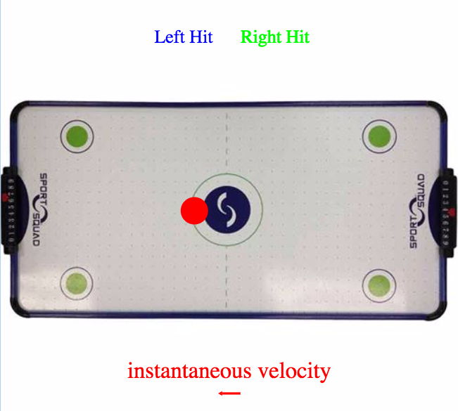

**Puck moves across a frictionless surface**

Link to student code: <https://goo.gl/TyG5jd>

For this stage, the table is working properly and will provide a completely frictionless surface. Students will enter an initial velocity for the puck and may provide forces to the puck as it moves by hitting the “left” or “right” arrow keys.

(The space bar works as a ‘pause’ button on all three pieces of the simulation.)

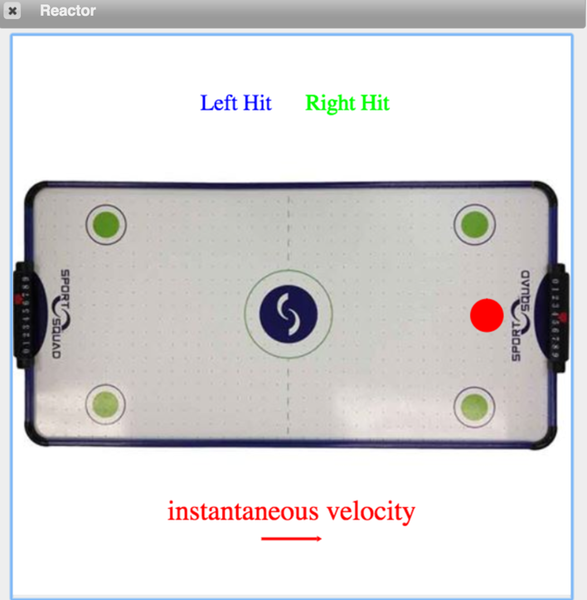Student Code and Output:

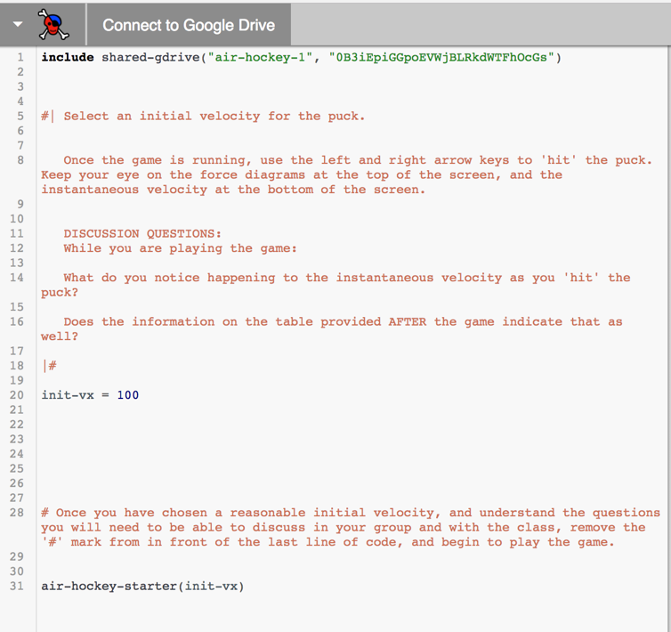

Students should pay special attention to the force diagram above the air hockey table (labeled as “Left Hit” and “Right Hit”) and the instantaneous velocity vector below. Because the force only appears when they hit the arrow key, it can blink rapidly and be difficult to detect. Holding down the key for a longer interval of time will produce a more visible arrow. The goal is to once again connect the direction of the sum of the forces with the direction of the change in velocity.

**Whiteboarding**

Follow this stage of the activity with a whiteboarding session. Ask students to predict what would happen if half of the air jets on the table were not working (choosing the right side will foreshadow the simulation in Activity 3b), meaning that half of the table was not frictionless. Have students draw a motion map and a velocity vs. time graph to illustrate their ideas.

Some questions to consider during the discussion:

* Which of these representations can be used to illustrate that friction is present on half of the table?
* Which representation would work regardless of the initial velocity of the puck?
* What would the function look like for the motion of the puck?

The motion map is the better representation here as it is on a position-based axis. Students should recognize that, at a position of 500 pixels (the midpoint of the table - the table is 1000 pixels across) the motion changes.

Since the motion of the puck changes halfway across the table, this is a piecewise function. Although students have written functions in Pyret in the previous unit, they have not yet written *conditionals* to format the function so as to have two distinct portions. During discussion, the use of *if...then* will produce a smooth transition into worksheet 2.

**WS 2: New Pyret Skill: Conditionals**

Simple conditionals (if… else) statements are used in this tutorial.

Have the students play “Where’d You Get That” again with their design recipes. Here are the instructions from Unit 2:

1. After students write their design recipes, they will defend their work to a neighbor.
2. Students turn to a different partner than they worked with on the design recipe.
3. Student A starts at the top of Student B’s paper and section by section asks their partner “Where did you get that?” as they point to different parts of the work.
4. The responding student must provide an answer from the previous section of the design recipe. For example, the first round Student A asks about the Physical Interpretations, and Student B must provide an answer from the function prompt.
5. Then Student B folds back the top of their paper so they can no longer see the functions prompt.
6. Student A now asks, “Where did you get that?” for components of the Contract and Purpose statement and Student B must provide an answer from the physical interpretations section.
7. Continue folding section by section through the function definition. Then switch partners.

Note: For question 10:

10. Write a new function called new-pizza-cost(...). It should consume a number of toppings and produce the price of the pizza.

The goal for this question is for students to recognize that a pizza with zero toppings will still cost something. So, we want a function like this:

|  |
| --- |
| cost-per-topping = 2  **fun** pizza-cost(n):  9 + n * (cost-per-topping)  **end** |

In the next question, students will have to add a conditional statement, which is the ultimate goal of the activity.

|  |
| --- |
| cost-per-topping = 2  **fun** pizza-cost(n):  **if** n > 3:  15  **else:**  9 + n * (cost-per-topping)  **end**  **end** |

The discussion surrounding this function should focus on how the condition of n > 3 was chosen as the condition of interest, as well as how to write the code.

**Stage B: Air Hockey Table - Broken**

**Student programs resistive force at halfway point**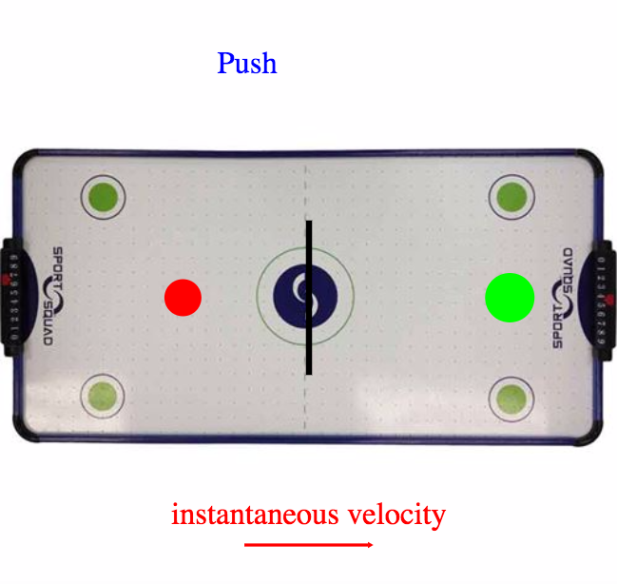

Link to student code: [goo.gl/LLQh9w](http://goo.gl/LLQh9w)

*Teacher Pyret Tip: Students may often need to adjust indentation in Pyret. To do so, they may select everything using CTRL-A, then use TAB to indent. This will readjust indentation properly.*

A video of the simulation has been included with the unit resources. This can be shown as an introduction to the simulation. It can be introduced that the air jets on the right half of the table are broken therefore only the left half is frictionless.

In this simulation students must use a conditional to tell the simulation to apply a resistive force to mimic friction when the puck reaches the midpoint of the table. Since the table is 1000 pixels wide, this means that the conditional should be set to be implemented at a position of 500 pixels.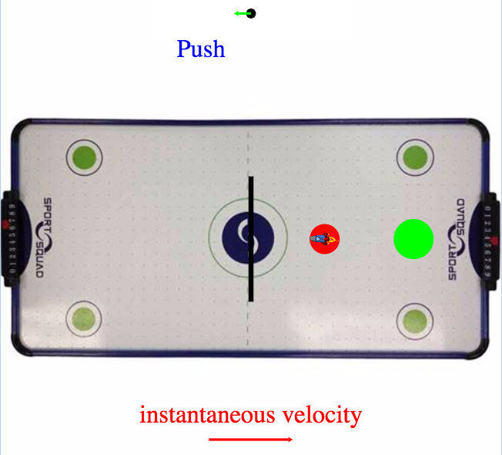

The goal is to make the red puck slow down enough to stop within the green circle. Again, the force vector is shown above the table (this time only the resistive force will be shown) and the instantaneous velocity vector is shown beneath the table. The black line indicates the midpoint and will disappear briefly as the puck passes this position, if the students correctly model the intended motion.

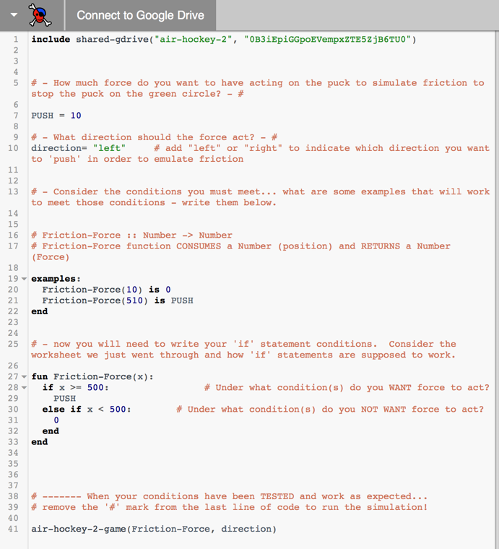Student Code:

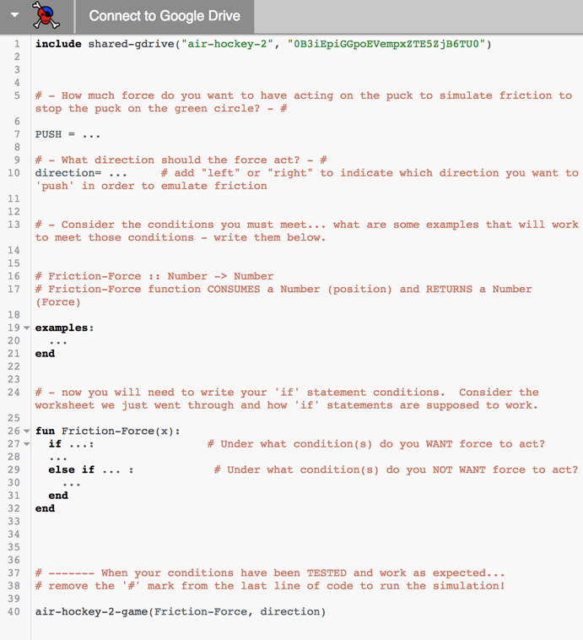

Questions students should consider during this stage of the activity:

* How much force must act on the red puck?
* Where is the force acting on the puck? Is that where the force is supposed to act? (Point students to the output table after the reactor runs to evaluate this, especially if it doesn’t work.)
* How do we get the ball to slow down?
* How do we tell Pyret to only have the force act once the puck passes the midway point?

Discussion ideas following this stage of the activity:

* In reality this force would be a frictional force, not a tiny rocket acting on the puck.
* The conditional is dependent on position, *not time*!
* The direction of the applied force is counter to the direction of motion. Connect this with the previous idea that the *direction of the sum of the forces* is the same as *the direction of the change in velocity*. The puck will accelerate if the force is applied in the same direction as the motion.
* Some students may achieve a success condition though their conditional statement does not apply the force when the position is greater than or equal to 500 pixels. Although this achieves a successful simulation, it does not meet the initial parameters set up in the activity. Point students back to the Motion Map and have them do a step by step analysis of *their* simulation against their motion map. (Reminder: The space bar works as a ‘pause’ button on all three pieces of the simulation.)

**Stage C: Air Hockey Table - Broken**

**Student programs force to counteract resistive force**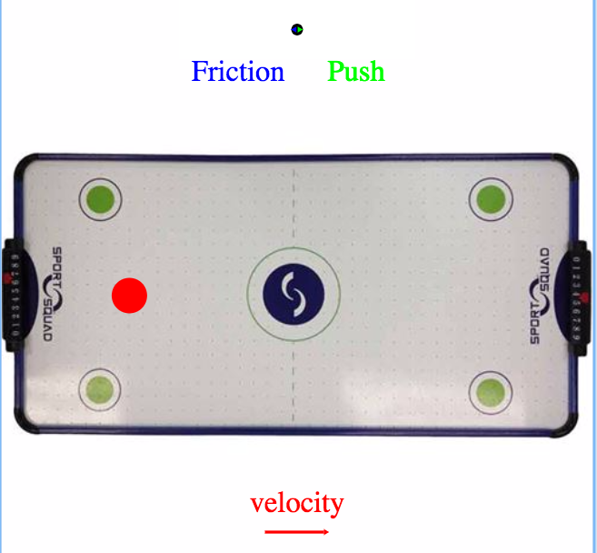

Link to student code: [goo.gl/R92Pxn](http://goo.gl/R92Pxn)

Reminder: The space bar works as a ‘pause’ button on all three pieces of the simulation.

A video of the simulation has also been included with the unit resources. This can be shown as an introduction to the simulation. It should be introduced that, for this simulation, the goal is to apply a force to the puck so that it moves with a constant velocity.

Once again, we see the broken air hockey table. Recall, the left side is working fine (frictionless), and the right side has friction. In the previous simulation, students provided the friction that slowed the puck down. This time, the friction has been pre-programmed and students must decide how to keep the puck moving the entire time, as if the air hockey table were working (meaning at a constant velocity).

The force vectors above the table are again present (the pre-programmed friction is shown in blue and the student-programmed push is shown in green) as is the instantaneous velocity vector below the table. Students should first program a value for the push, run the program, and then observe the relative size of the vector. Their goal is to determine a value for the push that will result in a zero sum of the forces.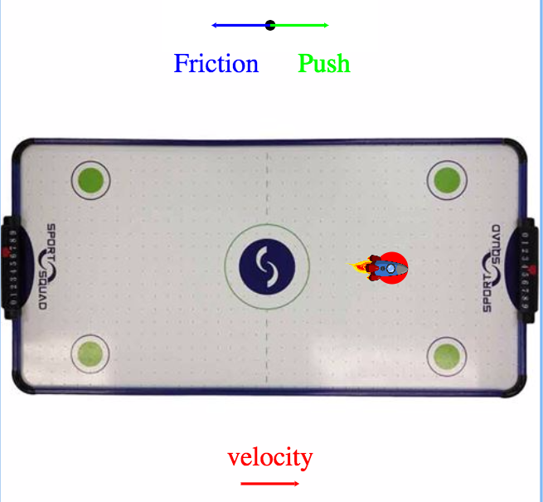

Questions students should consider during this stage of the activity:

* How much force must act on the red puck?
* When is the force acting on the puck?
* In what direction must the force act on the puck?
* How do we tell Pyret to only have the force act once the puck passes the midway point?

Discussion ideas following this stage of the activity:

* We get the puck to continue moving in the same direction if it was *hit* in that direction.
* In each stage the force caused a change in velocity, which is an acceleration, thus there is a connection between force and acceleration.

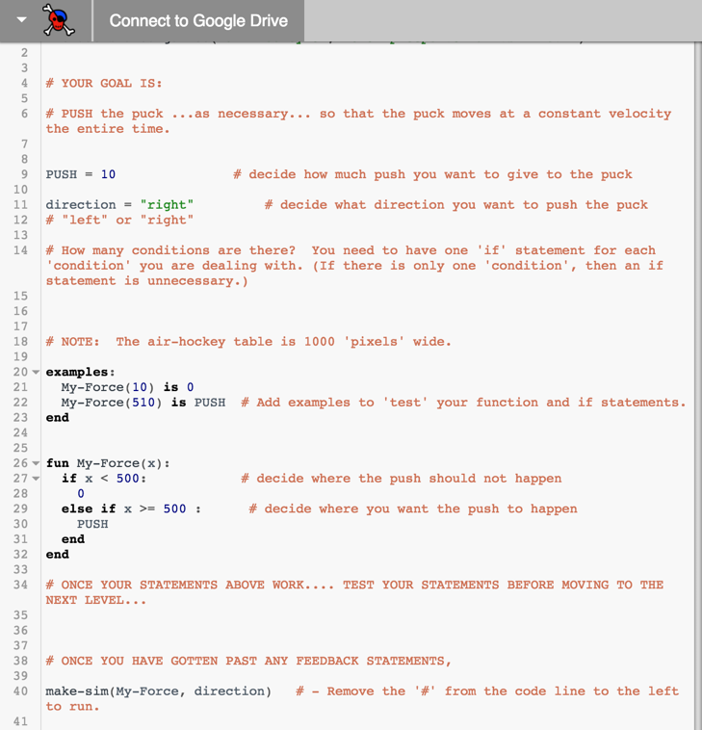Student Code:

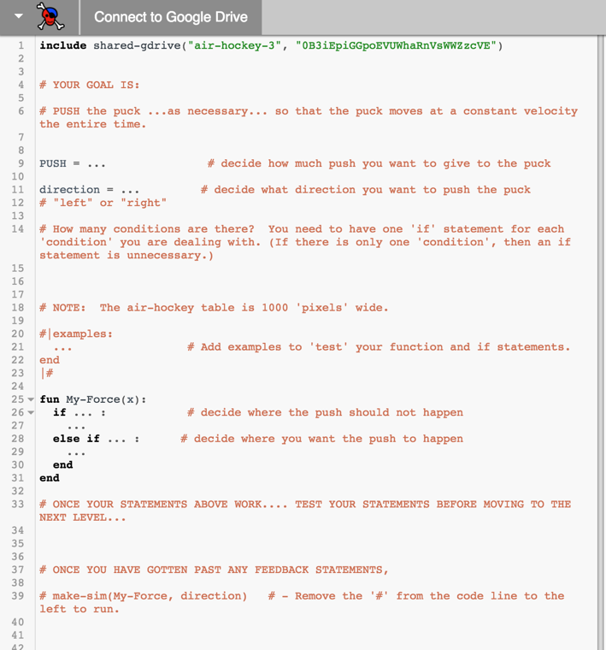

# 9. Worksheet 3: Hockey Table Analysis

**Goals:**

Students will demonstrate understanding of:

* Forces happen only as an interaction between objects.
* Forces act in specific directions, based on the type of interaction and the orientation of the scenario.
* Forces are balanced when the object experiences constant velocity (∑F = 0).
* Forces are unbalanced when the object experiences non-constant velocity (∑F ≠ 0).

# Activity 4: Pairs of Force Stations

## Pre-lab Discussion

This lab consists of several stations, each of which is designed to show students that the interaction between two systems results in a pair of forces equal in magnitude but opposite in direction.

# **Instructional notes**

This activity can be completed in two modes: high-tech or low-tech. The high-tech version requires pairs of force sensors, a pair of force plates and the appropriate interfaces while the low-tech version uses spring scales and carts, skateboards or rolling chairs that students can ride. For both versions care should be taken to effectively attach probes or scales to the objects used.

**High Tech:**

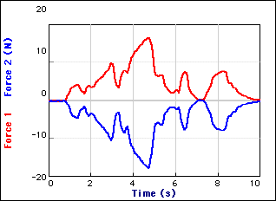This activity requires careful notation and careful zeroing of the force sensors. The full activity provides more than sufficient data to convince students of Newton’s 3rd Law, but only if the notation is clear and the force sensors are properly calibrated.

In every scenario, students should produce a graph similar to what is shown. It is important to define one of the force sensors as ‘push’ positive, and the other as ‘pull’ positive. Be sure that the graph shows the same.

In all cases, regardless of the circumstances, students shall see that the force on 1 on 2, is equal and opposite to 2 on 1. Point the attention of the students to the system schema. Highlight that this is a single interaction. The interaction is the same strength for both objects for *all times*. Ultimately, this will support the transition to investigating Newton’s 3rd Law.

F1on2 = -F2on1

**Low Tech:**

In the low-tech version, similar stations are used, substituting spring scales for force probes in scenarios that involve objects pulling one another and carts or skateboards for scenarios in which objects push one another.

Since the spring scales provide discrete rather than continuous data, data collection and representation is done via table. The goal is to have students recognize that the force exerted by object A is equal in magnitude to that of object B.

As in the high-tech version, system schema and force diagrams are used to highlight the single interaction.

# 11. Worksheet 4: Pairs of Forces

This worksheet reinforces the idea that Newton’s 3rd Law pairs are the result of one interaction between two objects. System schema and force diagrams using agent-object notation are used to represent this concept.

# 12. Activity 4: Gravitational Force vs. Mass Lab

*An experiment worksheet is included in the supplemental materials.*

## Apparatus

* Spring scale or force sensor and interface (Lab-Pro, ULI, Data Studio).
* Mass hanger and lab masses sufficient to allow 6 data pairs within range of scale (probe).

## Pre-lab discussion

The purpose of this experiment is to develop a mathematical representation to describe the effect of the gravitational field on matter.

* Hold an object above the table and let it go. Ask students what force(s) act on the object. Most, no doubt, will answer, "gravity." It's worthwhile to spend some time defining gravity as a long-range force exerted by one body (in this case, the Earth) on another. Ask students to identify the characteristics of some object that affects the force of gravity on it.
* While the mass of the object is the only significant characteristic, many others will be mentioned. Among other nominations may be air pressure, the height of an object above the floor, the object’s weight, etc.
* Ask what variables might be measured. Foster a consensus that the force of gravity and the mass are the significant variables and that they may be measured. Don't rush through this, however, as there's evidence that many students have a poorly formed concept of gravity. (See *Heavy Boots*)
* This is the first encounter with measuring forces. We simply grant that spring scales or force probes measure what we mean by “force” and that the unit we use for measurement is the newton (N).

## Performance notes

* Students will measure the force of gravity on various objects using spring scales. The masses of the objects can be measured by balances. It may be interesting to have a mislabeled mass, i.e. one that has a real mass different from the value stamped onto it.
* An alternative is to suspend a cup from the spring scale and to fill the cup with varying amounts of sand, determining its mass using a balance and the force of gravity using the spring scale.
* Groups will generate graphs of **Fg by E on m** vs. **m**.

## Post-lab discussion

* The equation of the regression line should be **Fg by E on m** = (9.8 N/kg) **m**
* Students can interpret the slope of the **Fg by E on m** vs **m** graph. We will call the slope **g**, the gravitational field strength of the Earth. Students will doubtless see a connection between the acceleration of an object in free fall and **g**. It is important to emphasize gravitational field strength, with units of N/kg, since this value was measured as a relationship between gravitational force and mass on a stationary object. Here we introduce the field concept that underlies electrical and magnetic fields, too. At this point, one should introduce "weight" as the common name for the force of gravity.

13. Class discussion – What are mass and weight and how are they related?

Veritasium – Mass vs. Weight

<http://www.youtube.com/watch?v=_Z0X0yE8Ioc>

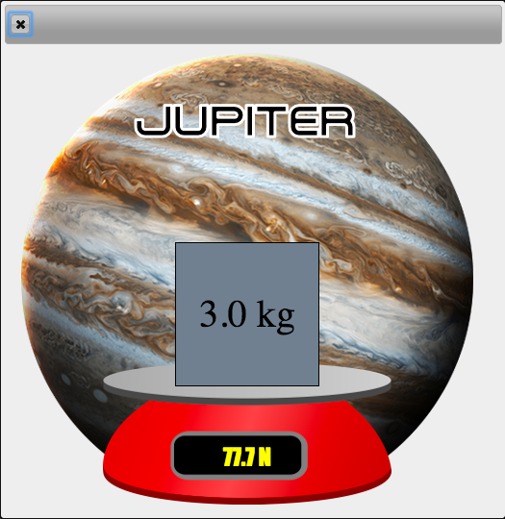14. Activity 5: Gravity on Different Planets Pyret Simulation

For this activity, students use Pyret to recreate the gravitational force lab they just completed on different planets. A table of mass vs. gravitational force should be constructed with the goal of calculating each planet’s individual gravitational field strength. Use of the phrase "gravitational field strength" and not "acceleration due to gravity" should be emphasized as the gravitational field acts on all objects in the field, not just those in free fall.

Prior to the lab, the pre-lab questions could be discussed in a whiteboarding session. It is important to discuss that scales measure normal force, but since the object being measured is not moving nor accelerating, the normal force is equal in magnitude to the gravitational force for the purposes of this lab.

Discussion should establish that the gravitational force can also be known as "weight."

*When the students are filling out the design recipe worksheet they must use the letters m and g in their function. They will receive a feedback message if they use the word “mass” instead of m.*

Student Code:

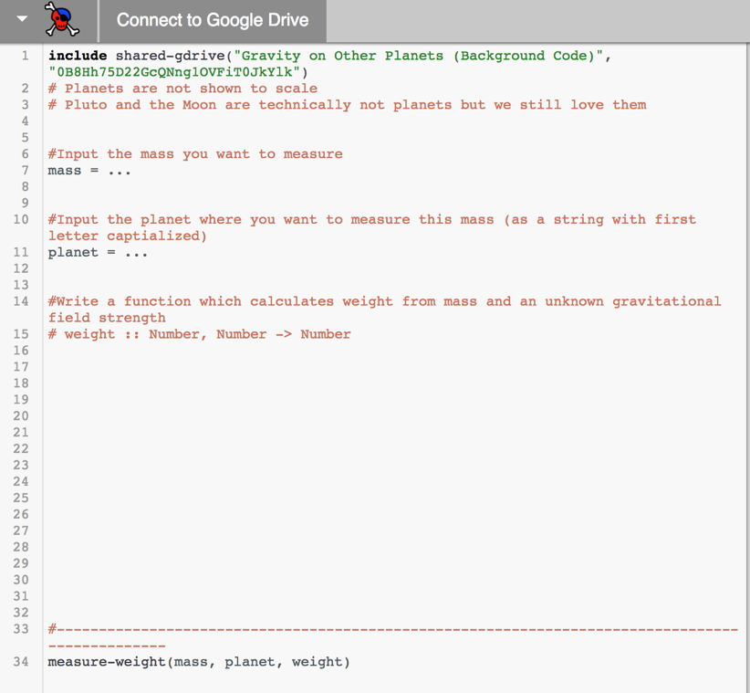Note: All eight planets of our solar system, plus Pluto and the Moon, are included in the background code for this simulation. The output will show their chosen mass on a scale with the reading for weight on that planet, shown in the background. Students may click on the output to zoom in.

Students should include both an examples block and function in the code.

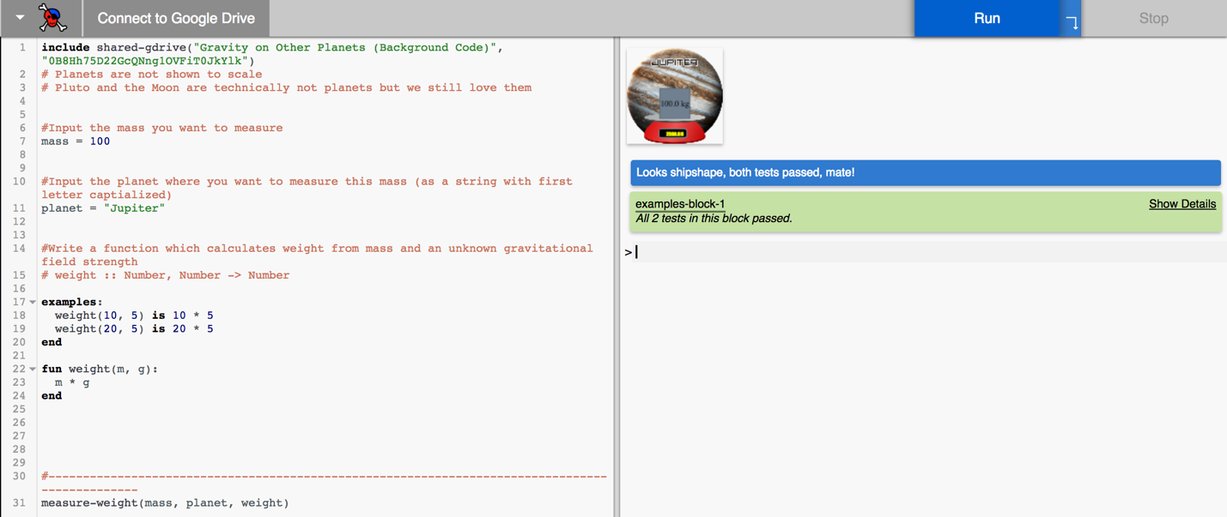

# 15. Reading 3: Force Fields

This reading is designed to unify gravitational and electric force fields, into a single concept commonly referred to as ‘field theory’. The basic concept is that regardless of the attractive nature of the gravitational force or the attractive/repulsive nature of the electric force, the magnitude of both force types follows the same pattern: F = m * gfs or q * efs.

16. Worksheet 4: Electric Force and Electric Fields

# 17. Activity 6: Millikan Oil Drop Practicum Pyret SimulationScreen Shot 2017-04-13 at 11

# Link to student code: [goo.gl/Dghuoq](http://goo.gl/Dghuoq)

# <https://www.youtube.com/watch?v=nwnjYERS66U>

# This video includes a very simple explanation of what Millikan was trying to do and includes some very important visuals to help our students conceptualize what is being discussed. As this screenshot illustrates, the upward force from the electric field is balanced by the downward force by the gravitational field.

In this activity, students are asked to write conditional statements for the force from an electric field as shown. The goal of the exercise is for the students to correctly code the conditions for electric field, such that the oil drop (shown at the top) experiences ‘free fall’ as studied in Unit 3 everywhere except where the oil drop is ‘in the field’. There are hints as to where the oil drop experiences the field, based on the numbers given and the picture of the oil drop. (The drop becomes an image of a plasma ball, rather than a steel ball when it is in the field.)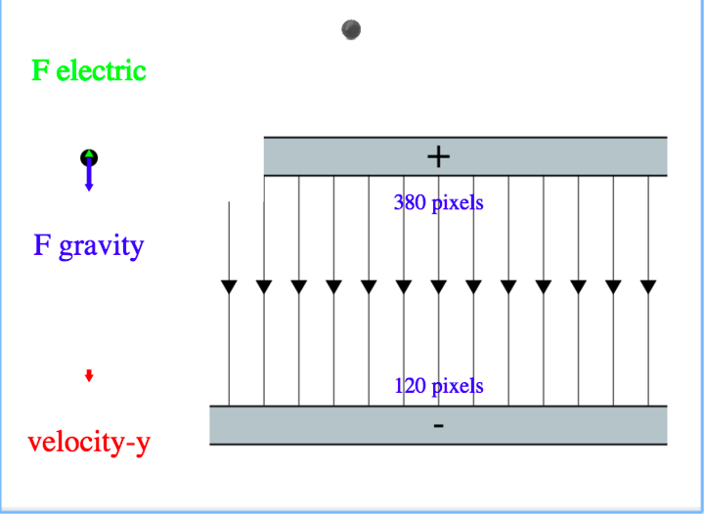

Note: There are 3 conditions to this sim, whereas the previous situations really only involved 2. Students will need to work out how to do this based on previous examples.

Student Code:

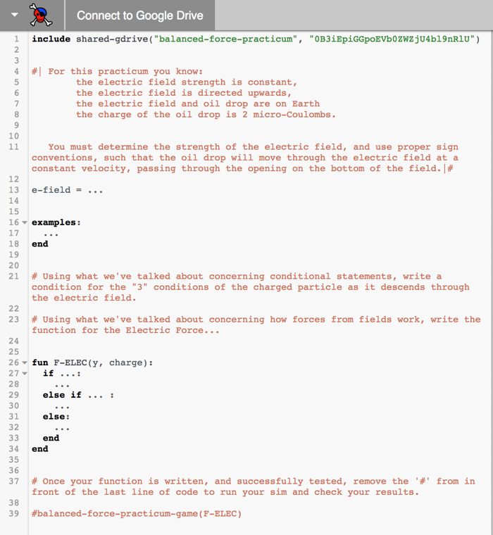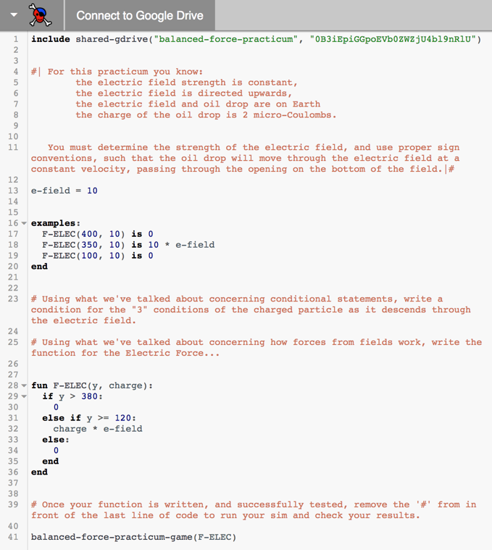

The expectation is that students will come up with something like the box on the right above, but if they are ‘clever’, they can write it in 2 conditions, but one of the conditions must be a compound condition.

|  |  |
| --- | --- |
| e-field = ...  fun F-ELEC(y, charge):  if ... :  ...  else if ... :  ...  else:  ...  end  end | e-field = ...  fun F-ELEC(y, charge):  if ... and ... :  ...  else:  ...  end  end |

# 18. Worksheet 5: Forces in Equilibrium

Opportunity for students to work out equilibrium problems.

* Practice system schemas
* Practice Force Diagrams
* Practice writing summation equations for vertical and horizontal directions
* Practice solving for various unknowns (specific forces, mass, etc.)

Question 6 offers an opportunity to begin the introduction of the **“megadot” concept (multiple object system).**

In this scenario, the problem becomes MUCH easier to solve if the 7 kg and 4 kg objects are thought of as a single entity, which we will refer to as a “megadot.” Be sure that students draw the full system schema, illustrating the two objects separately, and have them work out the force diagrams for EACH object separately.

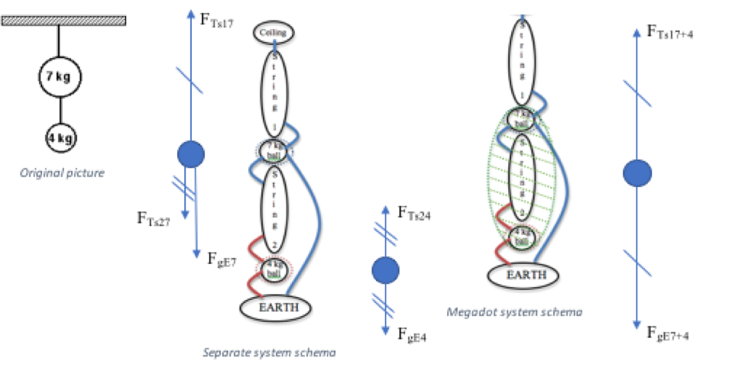

Afterwards, show that the force diagram for the 4 kg provides all the information needed to solve for the tension in the bottom string.

Solving for the tension in the top string is more complicated requiring action/reaction pairs on the bottom string. Using the “megadot,” where the 7 kg and 4 kg objects are one entity, a single force diagram can show that the tension in the top string is due to the weight of both masses.

In this case, there are two forces acting on the new green “megadot” system – one force of tension (the top string), and one force of gravity *for the system* as illustrated.

Then, the force diagram for determining the tension in the top string is the same as the force diagram for the bottom string.

There is a bit more effort required to develop this “megadot” concept, but the pay off in the future to tackle far more complicated situations is well worth the time to develop it.

# 19. Unit Review: The Model so Far

# 20. Unit Test

# Supplemental Materials

The supplemental materials address two-dimensional and two-body systems in static conditions. These topics may not be appropriate for all audiences, but when time permits, and/or your students are ready for it, these offer an opportunity to develop greater insights into the world in which your students live and will set your students up for greater success if they go on to study physics again in high school or college.

# 

# 21. Activity 7: 2-D Force Diagrams

## Purpose

The goal for this activity is to take the students through a step-by-step journey layering one idea on top of another, but *only after each individual concept is firmly understood*. By this point, students should be well acquainted with the difference between balanced and unbalanced forces and how each relates to the motion of an object.

## Apparatus

# Dynamics Track

* Ball or cart
* Ring stand
* Strings
* Hanging masses

## Pre-demonstration Teacher Background

* It has been discussed previously that the ‘normal’ force always acts perpendicular to the surface.
* It has been discussed previously that the tension forces from a string always acts parallel to the string.

## Performance notesDescription: hanging mass

This is primarily a qualitative discussion, but a quantitative discussion could easily be added as well.

* Start with a mass hanging from a string, and have your students whiteboard the scenario for the hanging mass as the system. They should be able to identify that the forces are balanced, the forces are gravitational and tension, and that the tension force is numerically the same as the gravitational force.
* Add a string to the mass and attach it so that the new string is pulling horizontally, and the original string is now angled upwards in the opposite direction. Have the students determine what the original string is doing now. Students should recognize that the original string is still ‘balancing’ the gravitational force, but it is now *also* balancing the horizontal tension. The original string’s tension can be thought of as the hypotenuse of a right triangle where the horizontal leg of the triangle is the same magnitude as the horizontal string’s tension force, and the vertical leg is the same magnitude as the gravitational force on the mass from the earth. (Optional: if the horizontal tension is determined using a spring scale - and the mass of the object is known, students can determine the amount of the tension [and verify it using a spring scale] in the original string using the Pythagorean theorem.)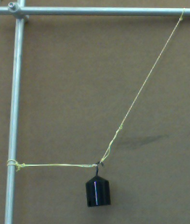



* The next activity in the sequence would be to examine a car on a flat track. Have the students whiteboard the force diagram and determine the values of the forces.
* Finally, incline the track and add a string to the car, parallel to the track. The students should once again whiteboard the force diagram, and determine what they can about the magnitudes of each of the forces. (The force of gravity will remain as it was before. The tension can be determined using a spring scale. Using Pythagorean theorem, with the force of gravity as the hypotenuse, and the spring scale as a leg of the triangle, they can find the other leg, which is the normal force. Surprisingly to many students, the normal force in this case is now smaller than it was before the ramp was angled. (Extension: Have students predict what will happen when the string is removed. This should remind them of the constant acceleration lab. Have them then explain why the car accelerates down the ramp based on the forces.)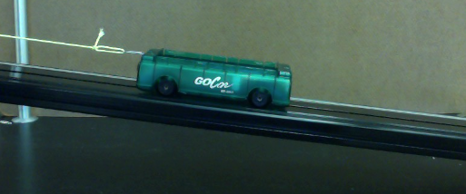

# 22. Worksheet 6: Force Diagrams 2

Opportunity for students to draw force diagrams with forces in 2-D, not just in 1-D. Highlight that the normal (perpendicular) force always acts perpendicularly to any stable surface that the system is in contact with. Also focus on the fact that strings, wires, etc. *pull* (rather than push) parallel to their direction of orientation and that rods, bars or poles exert pushes.

# 23. Quiz 2

# 24. Worksheet 7: Multiple Object Systems

Prior to the worksheet, the concept of “megadot” (multiple object systems) must be developed further. This concept will make the paradigm lab for Unit 5 much simpler. This method of solving problems makes solving more complex scenarios far more accessible to a larger section of students as it is far less taxing algebraically. The key is the use of the system schema to define the various parts of the larger system and the forces acting on those parts, before putting the entire system together into a “megadot.”

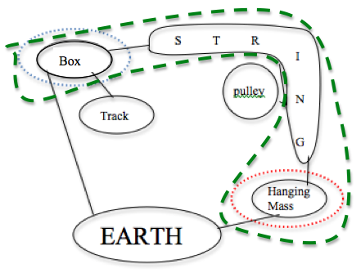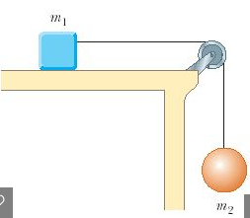

F

F

F

N by t on b

T by s on b

g by E on b

Force diagram for the box

f by t on b

F

T

# The force diagram for the box illustrates equilibrium, as the friction to the left balances the tension to the right.

The hanging mass illustrates that the tension and force of the Earth (gravitational force) on the hanging mass are balanced.

Note: The axes are labeled as ‘parallel’ (to the surface and string) and perpendicular (to the surface). These are not aligned, and need to be rotated to align them.

The forces acting parallel to the surface and the string can be treated as acting along one axis since, when the system is allowed to move, this is the direction in which it will move.

F

F

T by s on m

g by E on m

Force diagram for the hanging mass

F

g by E on m

Force diagram for the “megadot” system

F

N by t on b

F

g by E on b

f by t on b

F

T

# From here, we define the ‘megadot’ system as illustrated to the right. This leaves only 4 forces crossing the boundary of the system - 2 forces of gravity, 1 friction force, and 1 perpendicular (normal) force. The simplicity of this force diagram becomes clearly evident.

# The force diagram shows that the force of gravity on the hanging mass is the same magnitude as the friction force holding the entire system in equilibrium (using hash marks to indicate force magnitude equivalency is very helpful for seeing the balanced force situation). If the friction force were reduced or removed, the system (both the box and the hanging mass) would accelerate.

1. D. Hestenes, "Modeling games in the Newtonian World". *Am. J. Phys.* **60** (8), Aug 1992